Male Open Champions:
2025
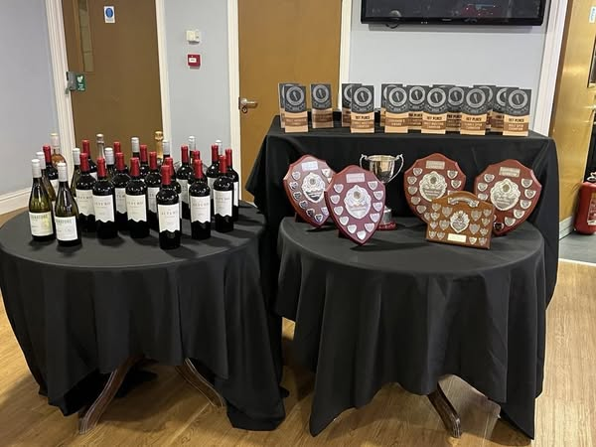
1st Jake Stephens
2nd Ben Engstrom
3rd Jon Hicks

Female Open Champions:
1st Julia Maddocks
2nd Juliette Hatt
3rd Vicky Fletcher

Male Masters Champions
1st Jon Hicks
2nd John Straiton
3rd Giles Archer

Female Masters Champions:
1st Julia Maddocks
2nd Juliette Hatt
3rd Melissa Holley

Best Newcomer Male
Andrew Harvey

Best Newcomer Female
Carla Burrows

Most Improved Male
Paul Griffiths

Most Improved Female
Rebecca Merrick

Lucy Jillings Cup
Alwyn Royall

Andy Merrills Shield
Lynda Bennett

Chair's award
Giles Archer

Male Open Champions:
2024
1st Jake Stephens
2nd Jon Hicks
3rd Ben Engstrom

Female Open Champions:
1st Julia Maddocks
2nd Emma Haley
3rd Vicky Fletcher

Male Masters Champions
1st Jon Hicks
2nd Alwyn Royall
3rd John Straiton

Female Masters Champions:
1st Julia Maddocks
2nd Julie Trudgeon
3rd Julie Bean

Best Newcomer Male
Lee Fenn

Best Newcomer Female
Jane Bolton

Most Improved Male
Ben Engstrom

Most Improved Female
Emma Haley

Lucy Jillings Cup
Vicki Bolton

Andy Merrills Shield
Frank Wainwright

Chair's award
Mark Barnett

Open championship male
2023
1st Jake Stephens
2nd Alwyn Royall
3rd Ben Engström

Open championship female
1st Julia Maddocks
2nd Juliette Hatt
3rd Julie Bean

Master championship male
1st Alwyn Royall
2nd Giles Archer
3rd Richard Smith

Master championship female
1st Julia Maddocks
2nd Julie Trudgeon
3rd Juliette Hatt

Best newcomers
Female Millie Turner
Male Ben Engström

Most improved
Female Joanne Donald
Male Nick Blair

Lucy Jillings Cup
Michael Bright

Andy Merrills Shield
Aine Halton-Hanley

Chair Lady’s award
Rohaise DV

Open championship male

1st Jake Stephens

2nd Krist Noonan
3rd Richard Smith
2022

Open championship female
1st Julie bean
2nd Nicola Ruth
3rd Julia Maddocks

Master championship male
1st Krist Noonan
2nd Richard Smith
3rd John Feerick

Master championship female
1st Julie bean
2nd Nicola Ruth
3rd Julia Maddocks

Best newcomers
Female: Serena Maskek
Male: Nick Blair

Most improved
Female: Liliana de Soto Reed
Male: Phil Barnett

Lucy Jillings Cup
Cameron Hutcheson

Andy Merrills Shield
Jake Henry

Chair Lady’s award
Michael Bright

Open Club Championship Male
1st Jake Stephens
2nd Rohan archer
3rd Peter Blake
2021

Open Club Championship Female
1st Michelle Maxwell
2nd Lilliana de Soto Reed
3rd Juliette Hatt

Age Graded (Masters) Male
1st Jake Stephens
2nd Alwyn Royall
3rd Peter Blake

Age Graded (Masters) Female
1st Michelle Maxwell
2nd Juliette Hatt
3rd Julia Maddocks

Best Newcomers
Female: Lillianna de Soto Reed
Male: Balazs Nagy

Most Improved
Female: Liz Laird
Male: Leigh Martin

Special Mention
Vicki Bolton and Peter Blake

Lucy Jillings Cup
Liz Barnett and Alex Ralton

London Marathon place
Rob Warwick

Chair Lady’s award
Neil Towers

All awards go to Covid-19 for cancellation of an entire year!

2020

Open Club Championship Male

1st Alwyn Royall

2nd Joe Hatt
3rd Richard Smith
2019

Open Club Championship Female
1st Juliette Hatt
2nd Julie Trudgeon
3rd George Wort

Age Graded (Masters) Male
1st Alwyn Royall
2nd Joe Hatt
3rd Richard Smith

Age Graded (Masters) Female
1st Julie Trudgeon
2nd Juliette Hatt
3rd George Wort

Best Newcomers
Female: Sally van de Burge
Male: Ian cox

Most Improved
Female: Emma Hinds
Male: Alwyn Royall

Lucy Jillings Cup
Nicola Johnson

London Marathon place
Georgina wort
Antonia Sarnago-Orchard
Andrew Craven

Chair Lady’s award
Julia Maddocks

Volunteer award
Adrian Sweetman

Open Club Championship Male

1st Alwyn Royall

2nd David Steele

3rd Peter Blake
2018

Open Club Championship Female*
1st Juliette Hatt
2nd Emma Hines
3rd Nicola Johnson

Age Graded (Masters) Male
1st Alwyn Royall
2nd David Steele
3rd Peter Blake

Age Graded (Masters) Female
1st Juliette Hatt
2nd Nicola Johnson
3rd Emma Hines

Best Newcomers
Female: Nicola Johnson
Male: Chris Stevens

Most Improved

Special Mentions
Michelle Maxwell and Nicky Finch (Training Efforts Sessions and Physical Prep)
Kelly Wariner (Fridays Progression, Beginners and keeping us on track)
Valerie MacDonald (Youth)
Frank Wainwright and Matt Penton (helping Ryan to progress and training up to marathon level)
Paul Wilcock, Andrew Craven, Sarah Ellis, Rohaise DV, John Feerick and Nicola James (Half Marathon committee)

Female: Dena Bray
Male: Ryan Simões-Hibberd

Lucy Jillings Cup
Becky O'Brien

London Marathon place
Nicola James
Chris Oakley
Richard Flesher

Chair Lady’s award
Mark Barnett

Open Club Championship Male

1st Tom Allen
2017

Open Club Championship Female
1st Debbie Jones

Age Graded (Masters) Male
1st Alwyn Royall

Age Graded (Masters) Female
1st Emma Hines

Best Newcomers
Female: Sandra Mylchreest
Male: Frank Wainwright

Most Improved
Female: Lynda Bennett
Male: Paul Wilcock

Lucy Jillings Cup
Becky O'Brien

Chair Lady’s award
Kelly Wariner

Best club Racer
Male: Mark Powell
Female: Rohaise DV

Performance of the Year
Cordula Hurcum

